Addition
R: 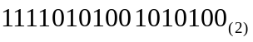
- 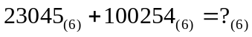 R: 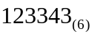
- 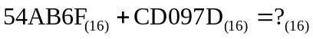 R: 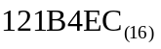
4. 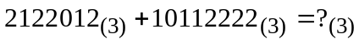 R: 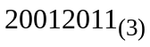
5. 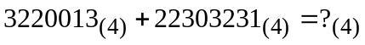 R: 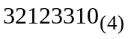
6.  R: 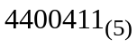
7. 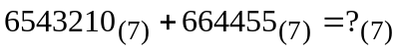 R: 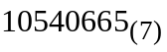
8. 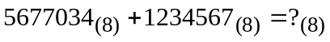 R: 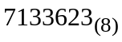
9.  R: 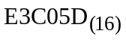
10. 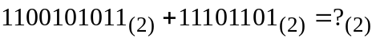 R: 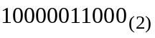

Subtraction
- 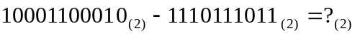 R: 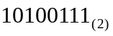
- 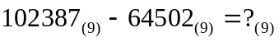 R: 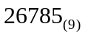
- 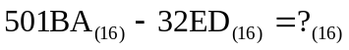 R: 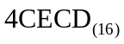
- 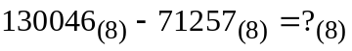 R: 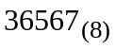
- 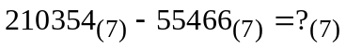 R: 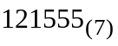
- 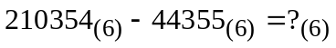 R: 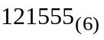
-  R: 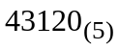
- 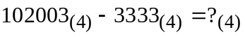 R: 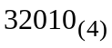
- 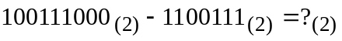 R: 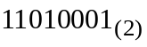
-  R: 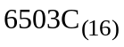

Multiplication by one digit
- 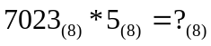 R: 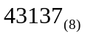
- 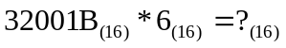 R: 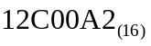
- 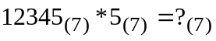 R: 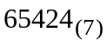
- 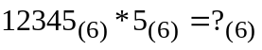 R: 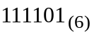
- 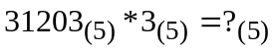 R: 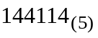
- 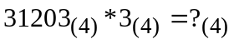 R: 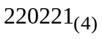
- 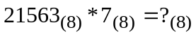 R: 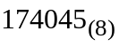
- 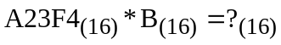 R: 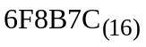

Division by one digit
- 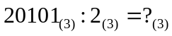
R: 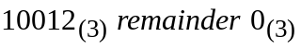
- 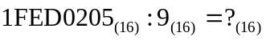
R: 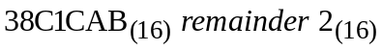
- 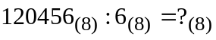
R: 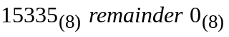
- 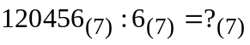
R: 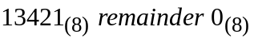
- 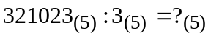
R: 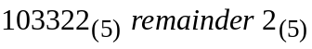
- 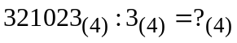
R: 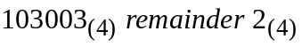
- 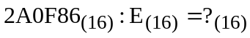
R: 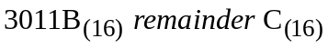
- 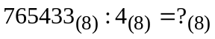
R: 